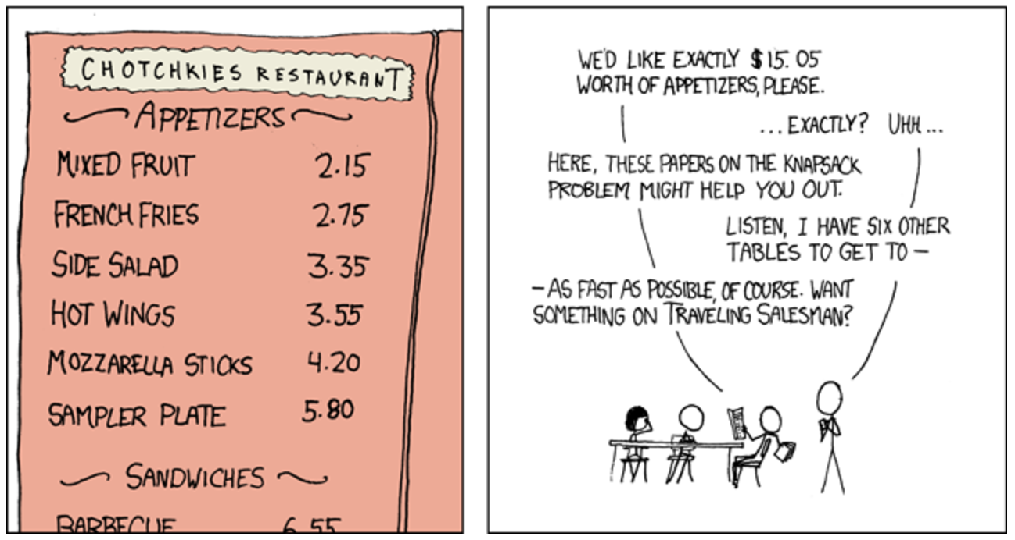My original search scenario was football, but I’ll change it to solve this exercise. Let’s say you are in a restaurant and you want to know what you can order for EXACTLY your budget of “n”.

A search tree would typically look like this: (assuming 0=initial state, 1=add Mixed Fruit, 2=add French Fries, 3=add side salad… 6=add sampler plate)

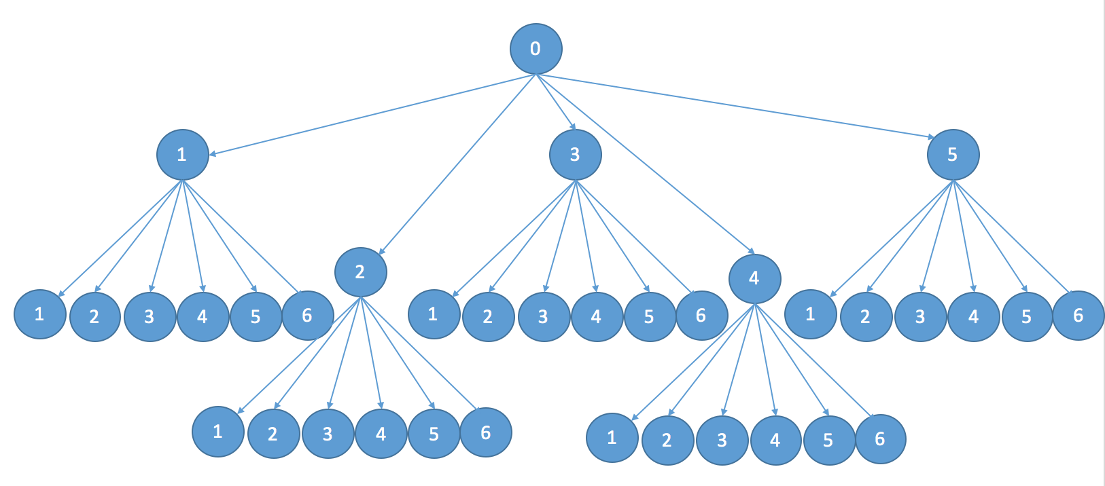**Depth-First Search**

Implementing a solution using Depth-First search would mean to add the first item in the menu as long as price fits the remaining budget (every action should substract from the budget) until the budget equals 0. If the budget doesn’t fit the first item in the least then the 2nd item would be proven to test, whenever non of the items fit the budget conditions, the latest item would be pulled out and the search would return to the previous state and evaluate the next possible 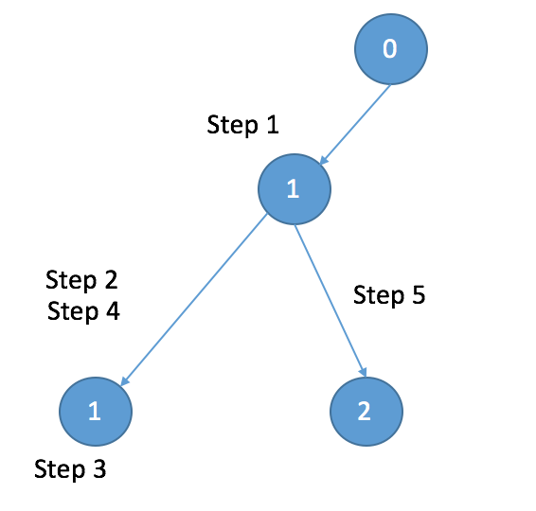option.

Given the previous search tree, lets assume we have a budget of 4.9

Step 1: add Mixed Fruit to the list. (Remaining Budget=2.75)

Step 2: add Mixed Fruit to the list. Again.(Remaining Budget=.6)

Step 3: iterate through items affordable with .6

Step 4: Since no Items were found, remove Mixed Fruit From the List and return to previous state. (Remaining Budget=2.75)

Step 5: Add French fries to the list (remaining budget=0, search is completed)

**Breadth-First search**

In this case we will evaluate all the possible options in the first state before jumping into evaluating another state. The search tree with a budget of 4.9 will look something like this:

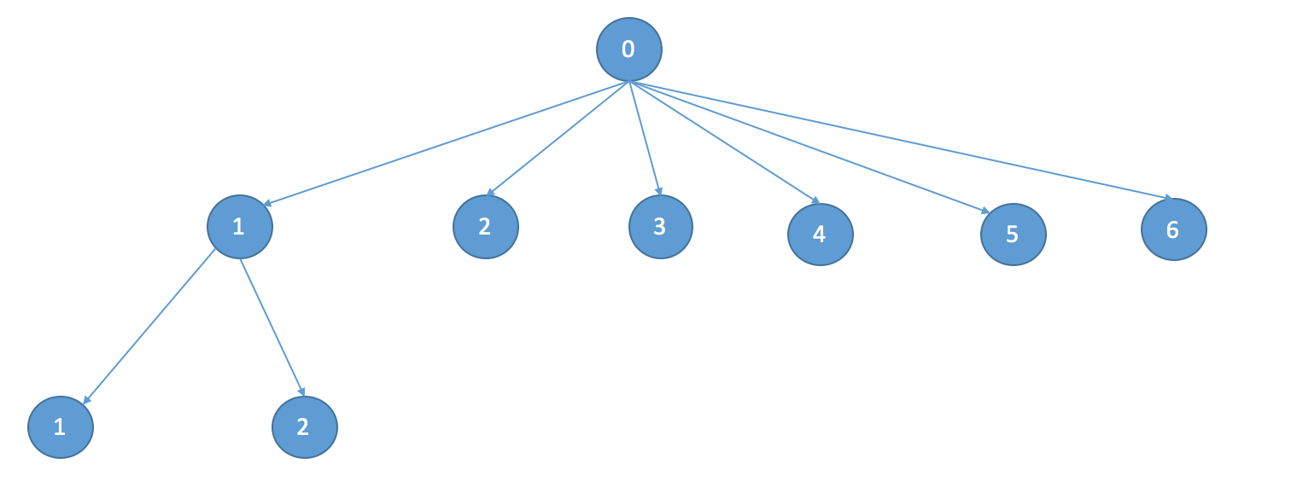

Step 1: evaluate adding Mixed Fruit. (Remaining Budget=2.75)

Step 2: Evaluate adding French Fries (Remaining Budget=2.15)

Step 3: Evaluate Adding Side Salad (Remaining Budget=1.55)

Step 4: evaluate adding hot wings (Remaining Budget=1.35)

Step 5: Evaluate adding mozzarella Sticks ((Remaining Budget=.7)

Step 6: evaluate adding sampler plate (cant afford)

Step 7: evaluate adding mixed fruit twice (Remaining Budget=.6)

Step 8: evaluate adding mixed fruit & French Fries (remaining budget=0, search is completed)